July 14, 2020 – 2pm Draft
With slide annotation & revised headers

Slide 1:
Course Outline for OIB-TAC creative art lessons
A multi-media guide for instructors to lead students who are VI/blind in two creative arts projects
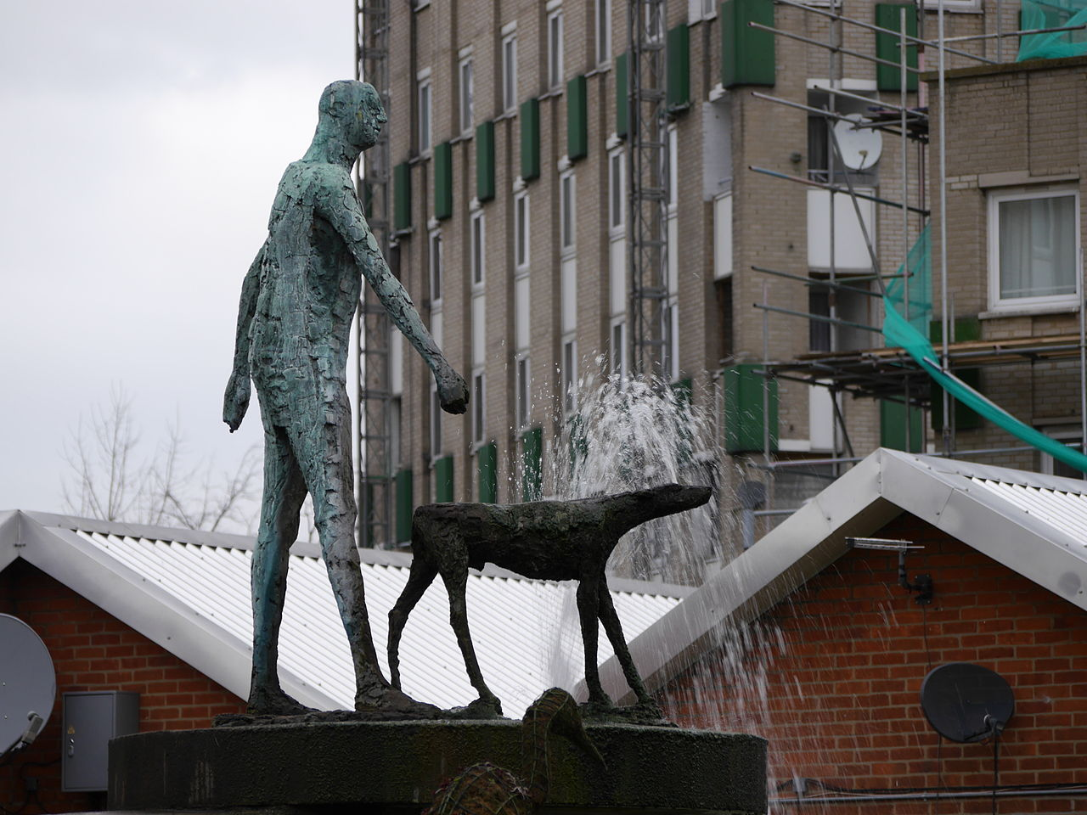
Braille Institute of America Arts Instructors: Simone Montemurno, MFA & Noah Haytin, MFA

Slide 2:
Topic 1: Rehabilitative Benefits of the Creative Arts for age 55+ and B/VI :
  - Neoplasticity: New skill acquisition, memory enhancement and organization of space to create a functioning workspace, self-organization, reinforcement of daily living skills. Realizing the vision retained in the “mind’s eye” for creative expression.

  - Socio-emotional benefits: Social space/time and expands sense of community encourages peer-to-peer support in shared experience and sense of camaraderie. Potentially alleviate struggle with depression, build confidence, encourage independence, offer a sense of purpose and a goal to achieve in the sense of pride and joy in completing a project that offers tangible evidence of their individual efforts. Fighting stigma of the limitations of blindness or low vision.
Slide 3:
  - Physical: manual dexterity, hand strengthening, tactile sensory awareness for object identification, and greater spatial awareness.

  - Cognitive: Memory, problem solving, experiments in problem solving, creative solutions. Offering a change in mode of thinking and judgement as per Cognitive Behavioral Therapy and re-framing ideas of progress, success, failure, learning. Encourage evaluative thinking about process rather than product. Offer meditative activities and give opportunity for presence in the moment.

Slide 4
Presentation Visuals: *Simone will create bold black and white drawing inserted here
  - Cartoon or something for each category of benefit (verbal description)
  - Picture of people with finished art works when they are completed/satisfied.
  - Illustrations with simple bold “thought bubbles”

Slide 5
Other resources:
  - https://visionaware.org/everyday-living/recreation-and-leisure/arts-and-crafts/setting-up-a-craft-area/
  - https://www.nytimes.com/2019/12/22/us/arts-health-effects-ucl-study.html
  - Quotes/Testimonials from art students about process etc.
Possible Q & A for assessing student data based on (SLO) student learning outcomes:
  - TBD Which of these 3 are the benefits to students could be in a specific category? (e.g. socio-emotional cognitive (e.g. raising tactile sensitivity is not one so it could be one of the three listed making that multiple-choice question not correct),

Slide 6
Topic 2: Workspace & Materials:
  - Set- Up:
    - Work surface: use a protective cover that considers the individuals specific vision (e.g. use a black or white paper as a covering for contrast).
    - Task Lighting: consider what position in room, lighting changes, facing away from sunlight, glare reduction (talk to John about this for benefits/terminology, etc.)
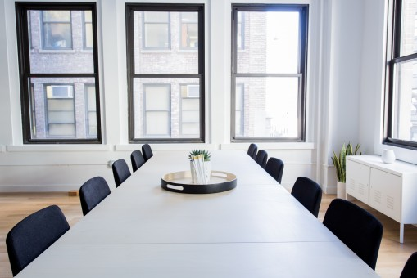

Slide 7

    - Adaptive devices to consider for magnification/contrast/illumination, a closed circuit (e.g. Da Vinci CCTV) monitor with an overhead camera that students can draw or modify viewing modes with. A lightbox to assist for backlighting in certain circumstances can be a helpful tool if available to VI students. Smartphone or tablet that can illuminate, enlarge, describe, photograph, etc. a given student’s project even in progress can assist with making viewing easier (e.g. a color-identification app be used).
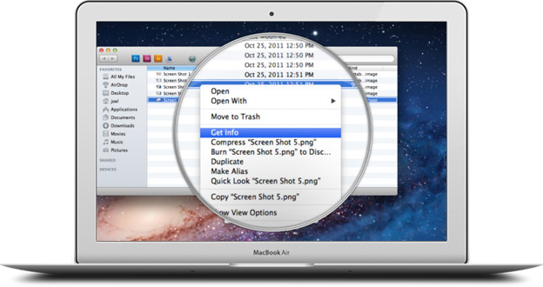
    - Ergonomics: Consider workplace: (if available) utilize adjustable chairs or props on the work surface that can lean and orient materials to make them easier to see/touch (an easel or block to prop up a flat work, marker/pencil/bush grip-aids.

Slide 8

  - Project types:
    - 2D: tactile collage: creating a collage that layers various textures, shapes, colors so that it can be appreciated as sensory experience with or without fully functioning physical site
    - 3D: papier-mache rock project: using basic paper mache techiniques to create a rock that demonstrates a student’s understanding of the media, tools, and techniques in creating a three dimensional form.

Slides 9, 10, 11 (once we divide this up per poject)
*I think we should break this list up per project (papier mache VS tactile collage)
    - Art Materials: Adhesives: white glue (e.g. Elmer’s), tacky glue (e.g. Aileen’s), Glue Sticks (purple can work well for increased contrast for VI students), masking tape, matte medium or strippable wallpaper paste
    - Brushes, brayers (for glue, inking and pressure)
    - Carboard/chipboard (from packaging supplies such as cake rounds).
    - Markers and pencils in a variety of shapes and thickness (triangle, bigger...scented for added sensory experience and another way to identify color!); black markers for bold line work (VI friendly)
    - Acrylic paint: Primary colors (red, blue, yellow), earth tones, & any metallics for added visual interest
    - Papers: newsprint, colored tissue paper, construction paper, textured papers (rice paper) or fabrics (mesh, rik rak) or any textured 2D materials that can be glued down.
    - Yarn, ribbon, string, pipe cleaners, wire, tin foil, saran wrap, variety of sized + shaped plastic containers), paper towels, zip lock bags, sandwich and re-sealable bags to organize materials are helpful tooks (these can be labeled with Braille if needed & instructors can prepare this in advance for students or assist students with organization).
    - Wiki Stix to create tactile lines to delineate shape/boundaries
    - Mixture of textured 3d objects (organic and inorganic...can be virtually anything you can glue down!) such as buttons, foam, ribbons of various texture, leaves, trinkets, beads, sewing notions, bark, rope, tassels, chains). *encourage natural materials. Not all of these are absolutely neccessary but pick what works for variety of texture, shape, and color.
Note: We should consider if it is best to just list materials and then mention their general uses (perhaps also note why it is a good choice of material for B/VI?).Then, during specific projects we can note more specific uses or action that needs to be done and how material assist /are effectively adaptive (e.g. wiki stick as raised line etc.).
Other resources:
  - National suppliers of various materials.
  - Link I found on set-up before (need to find).
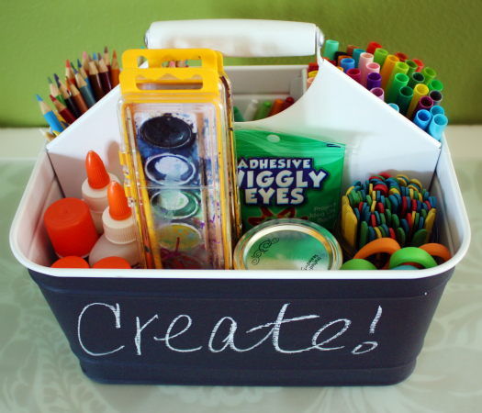

Slide 12

Topic 4: Vocabulary and/or Skills:
  - Highlight descriptive vocabulary and expanding available terms for identifying and describing objects
  - When we talk about describing things TO people who are B/VI we should point out it is good to relate it to an everyday object e.g. size of a fruit or body part/ cleaning material – spray etc... sponge rough or etc.

Slide 13

Presentation Visuals:
  - Pics of the arranged materials (a la a “cooking show” showing/listing ingredients and needed materials/tools).
  - Sample completed works noting what materials were used, how (utilize pointing arrows or other bold and easy to understand graphics)

Slide 14
Other resources:
  - National suppliers of various materials.
  - Link I found on set-up before (need to find).
  - Include links to inspirational stories by individuals living with blindness/vision loss

We will weave Presentation Visuals into all slides (this does not need to be a slide of its own)
  - Show people how to DO IT step by step in laymen’s terms but also introducing art vocabulary with definitions (Simone will create simple bold black & white illustrations for instructors)
  - Vocabulary: Definitions of art words: maybe have a few common examples and then links that go into more advanced as extension for more advanced learners
  - Notes on challenges or tricky things to expect “trouble shooting”
  - Definition of shapes, line, positive and negative space, symmetry (show how these can be used as basis for a lesson...

Slide 15

Follow up assessment/Q & A:
  - What is armature and what materials can be used as the armature for sculpture: e.g. tin foil, masking tape, string, pipe cleaner, sticks, foam core, etc.
  - Which adhesive is best for sticking paper flat? Which materials adhere well? Which did not? Why do you think that is and/or what did you learn from the experience?
  - Which of these is not a useful paper-mache binding material?
  - Share your work with someone who is blind/VI and have them explain it/interpret it to you; what materials do you feel worked best for a person who is blind/VI to understand your artwork?
Slide 16

Other resources:
  - Links to suggested and step-by step project instructions (e.g. paper mache & collage)
  - Artist for inspiration (Sister Corita Kent, sample images with description quotes/messages)
Slide 17

Topic 3: Prompts for discussing SLO (Student Learning Outcomes/Objectives) & Beyond
- Life lessons? What are student “take aways” from project? We can illustrate this by asking (a) student(s) we carry this out with prior.
- Ways prior knowledge can be applied so students sense they have skills and have a ‘toolbox’ they can already call on.
- Addressing and re-framing idea of “good,” “bad,” “success,” “failure” (understanding and enjoying the process).
- Discussion and promotion of learning and experimentation.
- Possible project extension: Introduce some 20th century art movements? (Surrealism.... ?) *If needed & not too much

Again these Presentation Visuals will be worked into slides (not a slide of its own):
  - Renowned artist work samples that are similar to project & completed and in-progress student work examples

Slide 18

Other potential resources:
  - Artist talks and interviews such as video clips
  - Student testimonials (perhaps we can record a virtual lesson with a student online & use clips from there)

We will work the below into other slides:
Further ideas to potentially include:
- When creating 3D artworks it's good to think of it like a body (e.g. human skeleton), the layers of muscle or fat built on top of the skeleton and the skin is the part of the surface where people can do detail etc. (there is a tendency for students to imagine completed project and want to start with the surface or final touches, but those must be led up to from the foundation working inside to out (e.g. you don’t make a cake a by starting with the frosting)
- Teaching samples (various stages of in progress work and finished examples of student artwork)

